CLG MEETING – MARCH 2026
ODOUR PERFORMANCE REVIEW

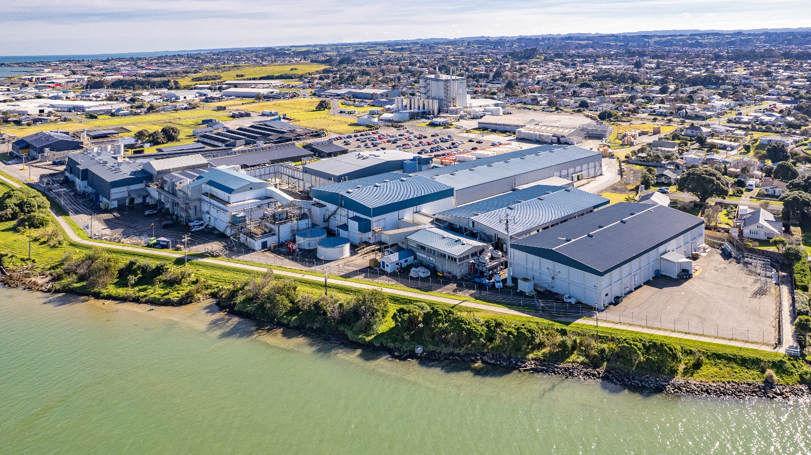
TABLE OF CONTENTS
- 2025 CLG Meeting Minutes.
- Current Odour Complaint Trends.
- Odour Complaint Register.
- Air Odour Discharge Consent Renewal Update.
- Improvement Opportunities.
- Plant Upgrades.

1. 2025 CLG Meeting Minutes
AFFCO IMLAY
COMMUNITY LIAISON GROUP MEETING – MARCH 2025

Date of Meeting: 25.03.25
Present: Walid Mahmoud - Imlay Plant Manager (WM); Ricky Gowan - Imlay Compliance Manager (RG); Dean Tucker (DM) – Operations Manager; Stephen Bryson (SB); Lonia Sarniak (LS) ; Hamish Lowe (HL).
Apologies :- Barbara Allan; Graham Pearson.
ACTIONS AGREED:
Subject | Action
Topics of Discussion and Agreed Actions | Meeting Agenda:-  - Review 2024 CLG Meeting Minutes;  - Current Odour Complaint Trends;  - Odour Complaint Register 2024 / 2025 period.  - Air Odour Discharge Consent Renewal.  - Improvement Opportunities.  - Air Discharge Consents Overview.  Minutes:-  RG:- Tabled meeting agenda. Covered outstanding issues from the 2024 CLG Meeting. Discussed current odour complaint trends. Consent Renewal:- Covered the community engagement letter and community responses (8 responses from over 400 community engagement letters issued).  SB:- Wanted to know what an ‘objectionable odour’ meant and why have a resource consent if objectionable odours were occurring beyond the boundary fence (this in regards to a substantiated odour complaint 27.02.25). Other topics concerns / issues raised by SB & LS included:-  - How can an objectionable odour have ratings (in ref to the FIDOL Assessment Form).  - AFFCO consistently produced odours and have done for years.  - No one else complains due to complacency and apathy.  - What other types of odours does Imlay produce within its processes.  - Untrained Armourguard rep performed a FIDOL assessment for odour complaint raised 21.02.25.  - Horizons actions in relation to odour issues.  - Who should be contacted if an odour is not an Imlay odour.  - Stated that if Imlay did a door knock engagement for the new consent that it would be a more accurate measure of community feedback.  HL:- explained the FIDOL process in regard to odour assessments and that not all odours were offensive – plus the difference between chronic and acute odour; odour producing elements of the rendering plant and equipment were explained; was noted that Porthill (Air Quality consultants) findings identified future improvement; covered the resource consent renewal process and details around gas fired boiler emissions and the proposed wood pellet burner – this included SB having an opportunity to have his say and suggest any concerns he has.  RG:- Noted that since the last consent there have been a significant investment in plant modifications – which were a requirement of the current consent. As technology has improved additional changes have been made and Porthills have identified further improvements which will be acted on in coming months; Stated that Horizons had activated Condition 10 in relation to the SB’s substantiated odour complaint on 27.02.25 and corrective actions have been made to incoming raw materials; once the application has been lodged SB will have the opportunity to raise his concerns during the consent process; where there were other odours which may not be AFFCO it was suggested SB contact the Pollution Hotline.  DT:- stated that AFFCO is the first meat exporting company in NZ to remove coal from their sites as part of their commitment to improve air quality and address new greenhouse gas requirements.  Meeting closed 18:20. Thanks to all those who attended.

2. Current Odour Complaint Trends

Compliance Period | 17 - 18 | 18 - 19 | 19 - 20 | 20 - 21 | 21 - 22 | 22 - 23 | 23 - 24 | 24 - 25 | 25 - 26
Substantiated | 5 | 39 | 3 | 1 | 24 | 1 | 1 | 3 | 2
Unsubstantiated | 13 | 26 | 12 | 3 | 20 | 13 | 6 | 8 | 5
Total Complaints | 18 | 65 | 15 | 4 | 44 | 14 | 7 | 11 | 7

Points of Interest:

1. 2 substantiated odour complaints to date for the reporting period, of which none were rated as objectionable (if it occurred on a regular or frequent basis) by the independent assessor. One of the odour complaints was rated as objectionable beyond the boundary fence in Heads Road (but not at the complainants address) by AFFCO staff. This odour was caused by a vacuum pump failure (PSES System).

2. Easy Earth Composting, located in Karoro Road, is another business which is producing odours within the Heads Road industrial area. Easy Earth Composting odours are very noticeable on Thursday’s when they turn their compost over. AFFCO Imlay representatives have laid one complaint to Horizons to date. This occurred on Thursday the 5th of March. Easy Earth Composting was approached by a Horizons official and advised of the complaint.

3. Odour Complaint Register
2025 – 2026 Reporting Period:-
ODOUR COMPLAINTS REGISTER 2025 - 2026
(Period from the 1st of May 2025 to 30th of April 2026)
Nº | NAME | ADDRESS | DATE | TIME REPORTED | TIME OF INVESTIGATION | COMMENTS | SUBSTANTIATED (Ours) | UNSUBSTANTIATED
1 | Stephen Bryson | 7 Saunders Place | 05.05.25 | 15:56 | 16:12 | Complaint made on AFFCO odour phone. Horizons and Armourguard contacted. Armourguard completed a FIDOL assessment and did not detect an odour beyond the boundary fence. |  | ✓
2 | Stephen Bryson | 7 Saunders Place | 22.07.25 | 15:40 | 15:55 | Complaint made on AFFCO odour phone. Horizons and Armourguard contacted. Armourguard completed a FIDOL assessment and did not detect an odour beyond the boundary fence at the time of their assessment, however as a result of an earlier breakdown in the Rendering Plant and subsequent start-up, the Compliance Manager and Night Shift Supervisor detected an objectionable odour beyond the boundary fence. During the process of start-up, a vacuum pump had failed which resulted in the PSES to fail (Point Source Extraction System) which resulted in fugitive odours to disperse to atmosphere. Refer Complaint Report for further details. | ✓
3 | Stephen Bryson | 7 Saunders Place | 03.12.25 | 17:13 | 17:25 | Complaint made on AFFCO odour phone. Horizons and Armourguard contacted. Armourguard completed a FIDOL assessment and did not detect an Imlay odour beyond the boundary fence. Compliance Manager - Ricky Gowan - carried out a FIDOL assessment and detected Open Country odours. No odours from Imlay Rendering Plant. |  | ✓
4 | Not known | 49 Balgownie Ave | 10.12.25 | 13:23 | 13:33 | Complaint made directly to Imlay Compliance Manager - Ricky Gowan. Horizons and Armourguard contacted. FIDOL assessments completed. Odours were not coming from Imlay. There was a definite compost odour emanating from 'Easy Earth Compost' located on Karoro Road. |  | ✓
5 | Not known | Balgownie Ave | 10.02.26 | 19:02 | 19:10 | Complaint made to Horizons at 17:00 from a resident in Balgownie Ave - address number not given. Horizons contacted Imlay at 19:02. Night Shift Production Supervisor - Greg Stanley - performed a FIDOL assessment at the boundary and could not detect any odours emanating from the rendering plant. There was however an 'Easy Earth Compost' odour detected earlier that night. |  | ✓
6 | Ron Thomas | 33a Bignell Street | 11.02.26 | 18:42 | 18:52 & 19:10 | Complaint made on AFFCO odour phone. Horizons and Armourguard contacted. Armourguard completed a FIDOL assessment and did detect an Imlay odour beyond the boundary fence but rated the odour as 'not objectionable'. Night Shift Production Supervisor - Greg Stanley - carried out a FIDOL assessment on the boundary fence and could not detect any odours. | ✓
7 | Not known | Caius Ave | 25.02.26 | 18:38 | 18:48 | Complaint made to Horizons from a resident in Caius Ave - address number not given. Resident stated that the initial impression was at 17:30. Horizons contacted Imlay at 18:38. Night Shift Production Supervisor - Greg Stanley - performed a FIDOL assessment at the boundary fence and could not detect any odours emanating from the Imlay rendering plant. There was however an 'Easy Earth Compost' odour detected earlier in his FIDOL assessment. Compliance Manager - Ricky Gowan - also went to Caius Ave and surrounding streets and could not detect any odours (the wind was very light, shifty and would have picked up odours from stock trucks driving along Heads Road). Armourguards FIDOL assessment also could not detect any odours. The complaint has been rated 'unsubstantiated'. |  | ✓

4. Air Odour Discharge Consent Renewal
The following is a timeline of events to date in regard to AFFCO Imlay’s Air Odour Discharge Consent renewal:-
- 31.03.25:- Issued consent applications to Horizons:-
- To discharge of particulate emissions to air from the operation of a 10.5 MW natural gas boiler (formerly ATH-2007010926.01);
- To discharge of odour emissions to air associated with various activities from AFFCO Imlay Processing Plant (formerly ATH-2017201595.00);
- 19.05.25:- Section 92 (additional information request) issued by Horizons.

- 24.03.26:- Currently with Horizons technical advisor.

5. Improvement Opportunities
Porthill consultants performed an assessment of the Imlay rendering air extraction systems last week and have identified a couple of improvements that AFFCO intend to implement once the report has been issued.

6. Plant Upgrades
Plant upgrades in the last 12 months have been:-

- Outside Raw Bin:- New raw bin installed.

- Blood Drier:- Extra vapour extraction feed line.

- Waste Heat Evaporator:- New condensate pump installed to improve vacuum.

- Meal Drier:- Extra vapour extraction on meal drier feed conveyer.

